Nguyễn Kiều Trang – 20205174 <6A – 8B – 6C>

**6A.**

.data

input: .asciiz "Input N: "

Error: .asciiz "Interger should be positive! Please enter try again.\n"

result: .asciiz "The integer in octal system is: "

.align 0

res: .space 80

.text

main:

#Input N

la $a0, input #address of input integer

li $v0, 4 #system call for string display

syscall

li $v0, 5 #read interger system call

syscall

move $s0, $v0 #store first integer in s0

#check positive

blez $s0, error

#print result messenger

la $a0, result #address of result mess

li $v0, 4

syscall

# Change

li $t0, 8

la $s1, res # $s1 luu dia chi co so cua res

li $t2, 0 # bien dem index i

Solv:

div $s0,$t0

mflo $s0 # thuong cap nhat vao $s0

mfhi $a0 # phan du = $t1

pushStack:

sb $a0,0($s1)

beqz $s0,Exit

addi $t2,$t2,1

add $s1,$s1,1

jal Solv

error:

la $a0, Error #address of error mess

li $v0, 4

syscall

j main

Exit:

li $v0,1

Loop:

bltz $t2,ExitLoop

lb $a0,0($s1)

syscall

addi $t2,$t2,-1

add $s1,$s1,-1

jal Loop

ExitLoop:

---------------------------------------

N = -2 -> Yêu cầu người dùng nhâp lại số dương.

N = 100

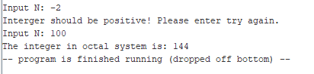

N = 6

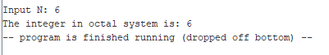

N = 12

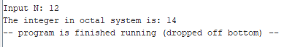

**B8**

.data

inputN: .asciiz "Nhap so phan tu trong mang: "

inputArr: .asciiz "Nhap mang:\n"

error: .asciiz "So phan tu phai la so duong. Vui long nhạp lai !!!!\n"

mess1: .asciiz "So nguyen am lon nhat la: "

endl: .asciiz "\n"

mess2: .asciiz "Vi tri cua so do <tinh tu vi tri so 0>: "

.align 2

A: .word #mangsonguyen

.text

la $s0,A

add $t0,$zero,$s0

li $s2,-100000 # max hien tai

li $s3,0 # vi tri tim thay max

get_num:

#so luong phan tu

la $a0, inputN # In dong inputN

li $v0, 4

syscall

li $v0, 5

syscall

blt $v0,0,error1

add $s1,$zero,$v0 #s1 = n - so luong phan tu cua mang

li $t1,0 #index i =0

la $t0,A

# Nhap mang A

la $a0, inputArr #In dong inputArr

li $v0, 4 #system call for string display

syscall

get_arr:

beq $t1,$s1,end_get_arr

li $v0, 5

syscall

bgez $v0, continue

check_max:

bgt $v0,$s2,update_max

jal continue

update_max:

move $s2,$v0 # gan gtri v0 vao s2

move $s3,$t1 # gan gtri t1 vao s3

continue:

sw $v0,0($t0)

addi $t0,$t0,4 #

addi $t1,$t1,1 #i++

j get_arr

#In loi neu so phan tu trong mang be hon 0

error1:

li $v0, 4

la $a0, error

syscall

j get_num

end_get_arr:

# in mess1

li $v0,4

la $a0,mess1

syscall

#in so am lon nhat

li $v0, 1

move $a0,$s2

syscall

# in \n

li $v0,4

la $a0,endl

syscall

# in mess2

li $v0,4

la $a0,mess2

syscall

# in vi tri index

li $v0, 1

move $a0,$s3

syscall

----------------------------------------------

* Số phần tử trong mảng: -5

Yêu cầu người dùng nhập lại.

Số phần tử trong mảng là 6

Arr = { -1, 0, 2, -8, -6, 3}

* Kết quả: Số âm lớn nhất là: -1. Ở vị trí số 0 <tính từ vị trí 0 đến N – 1>.

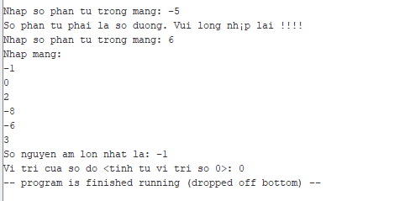

* Tương tự

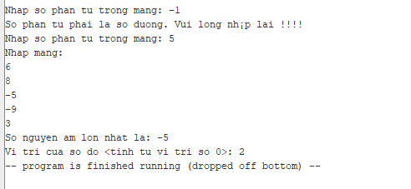

**C6**

.data

mss1: .asciiz "\nNhap xau: "

mss2: .asciiz "\nNhap ky tu C: "

result: .asciiz "\n\n=>>So phan tu C trong chuoi la: "

.align 0

string: .space 100

.text

#get_string

la $t1,string

get_sting:

li $v0,4

la $a0,mss1

syscall

li $v0, 8

la $a0, string

li $a1, 100

syscall

get_char:

li $v0,4

la $a0,mss2

syscall

li $v0, 12

syscall

move $s0,$v0 # $s0 luu gia tri cua ky tu can tim

#lay do dai xau da nhap

li $t0,0 # count

la $t1,string

get_length:

lb $t2,0($t1)

beq $t2, $zero, end_of_str # is null char?

addi $t0, $t0, 1 # $t0 = $t0 + 1 -> i = i + 1

addi $t1,$t1,1

j get_length

#xu li do dai xau, de thuc hien vong lap

end_of_str:

move $s2,$t0 # $s2 luu so luong ky tu trong xau

count_sque:

li $t0,0 # index loop i

la $t1,string # dia chi co so cua xau

li $s3,0

loop:

lb $t2,0($t1)

beq $t2, $zero, end_of_loop # is null char?

xor $t3, $t2, 0x20 # ky tu in hoa

addi $t0, $t0, 1 # $t0 = $t0 + 1 -> i = i + 1

addi $t1,$t1,1

beq $s0,$t2,update_count

beq $s0,$t3,update_count

jal loop

update_count: addi $s3,$s3,1

jal loop

end_of_loop:

li $v0,4

la $a0,result

syscall

li $v0,1

move $a0,$s3

syscall





